SOUTHERN BELLE SCOOPS N SWEETS MENU

BOOT SCOOTIN’ SHAKES
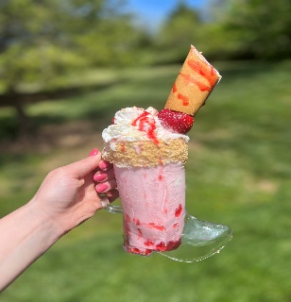

FLAVORS: S’MORES, BIRTHDAY CAKE, STRAWBERRY SHORTCAKE, COOKIE MONSTER

COWBOY HAT SUNDAES

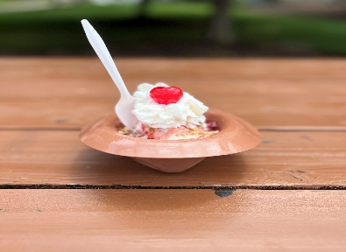

FLAVORS: HOT FUDGE, CARAMEL, STRAWBERRY, TURTLE

MILK SHAKES
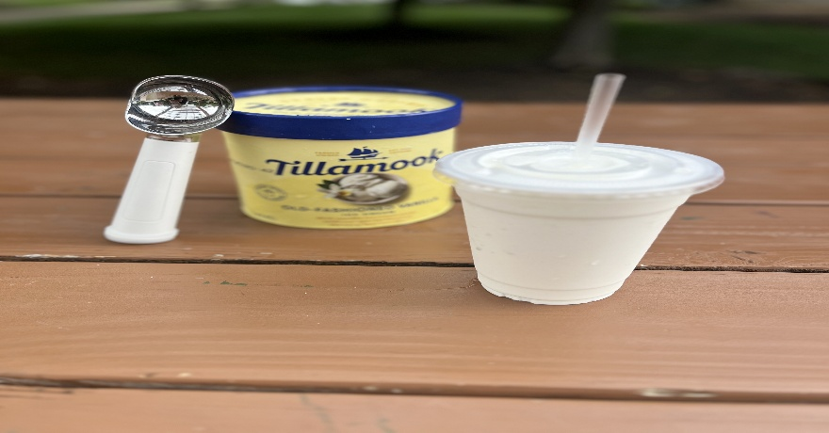

FLAVORS: STRAWBERRY, CHOCOLATE, VANILLA, OREO

TWISTERS
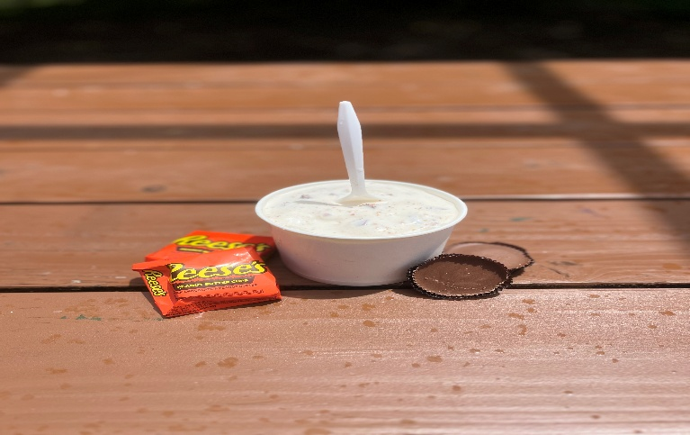

FLAVORS: VANILLA BASE MIXED WITH YOUR FAVORITE CANDY

FLOATS
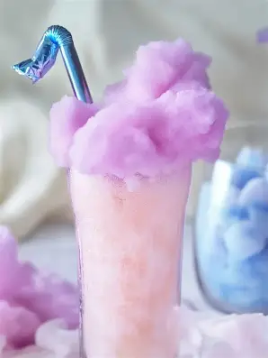

FLAVORS: COTTON CANDY OR ROOTBEER

ICE CREAM
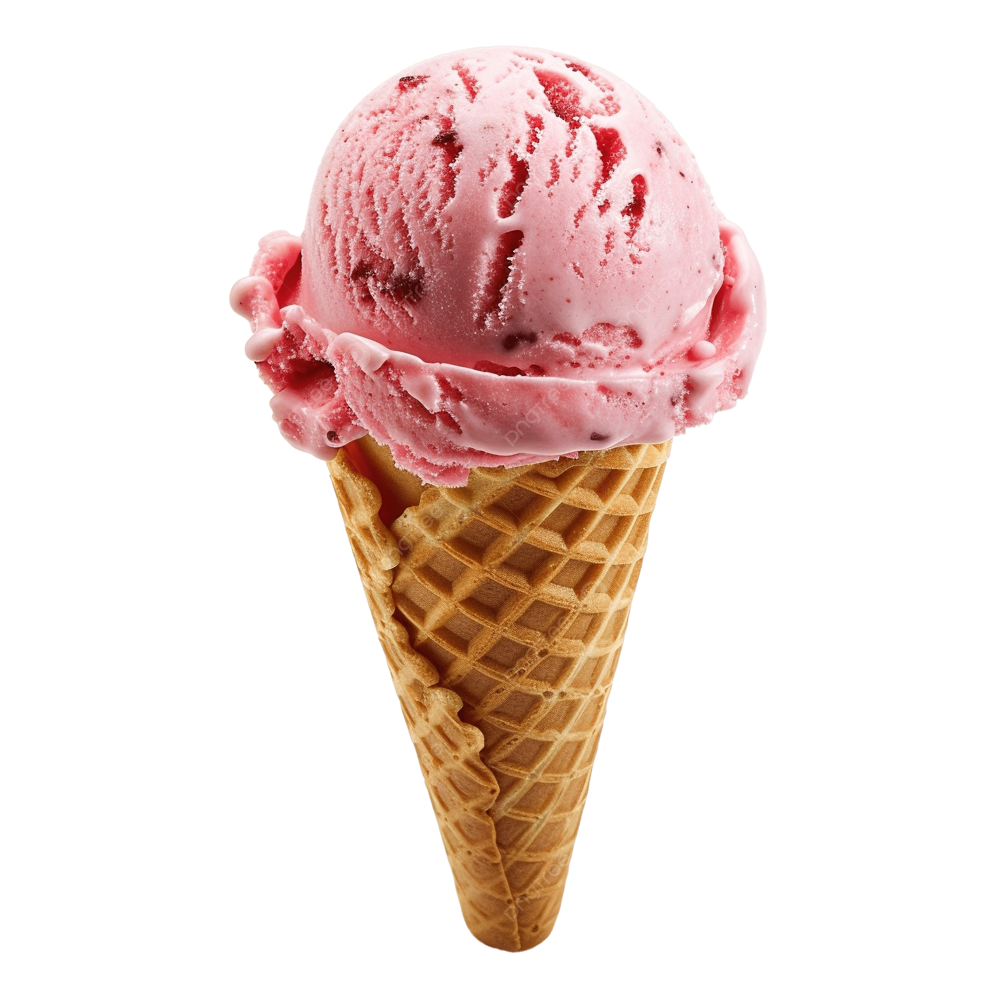

FLAVORS: OLD FASHION VANILLA, CHOCOLATE CHIP COOKIE DOUGH, CHOCOLATE, BUTTER PECAN, CHOCOLATE PEANUT BUTTER, WHITE CHOCOLATE RASPBERRY, VEGAN VANILLA

